Aerial Chinook Salmon Redd Survey Methods
In 2024, the California Department of Water Resources Feather River Section Office began using DJI Phantom 4 RTK and Matrice 4E RTK UAVs to fly flight route missions above Chinook salmon spawning locations in the lower Feather River to obtain images of Chinook salmon redds. The flight routes are created by drawing polygons around spawning locations using DJI’s GS RTK app on the UAV’s handheld flight controller. Flight route information such as speed, altitude, course angle and photo overlap parameters is entered into the app once the polygon is completed (Figure 1). After the UAV is launched it automatically ascends to the assigned altitude and takes one photo every second while flying the route. The UAV will take 20 to over 600 photos depending on the size of the flight route. A total of 15 flight routes were created for the low-flow channel (LFC) and 18 for the high-flow channel (HFC) (Appendix A, B, and C). Each flight route is designed to cover one or multiple spawning locations, and the exact same flight routes are repeated weekly or every other week depending on the spawning location(s) (Appendix A).

The UAVs utilize D-RTK2 (Phantom 4) or D-RTK3 (Matrice 4E) base stations that establish real-time kinematic (RTK) connection to provide better positioning accuracy when the drone flies a flight route (Figure 1). The base station acts as a reference point, transmitting correction data to the drone’s onboard receiver, which then uses this data to significantly improve the accuracy of its location information. The base station continuously receives signals from satellites in the Global Navigation Satellite System (GNSS) and collects data on atmospheric conditions, satellite positions, and other factors affecting positioning accuracy of the drone.
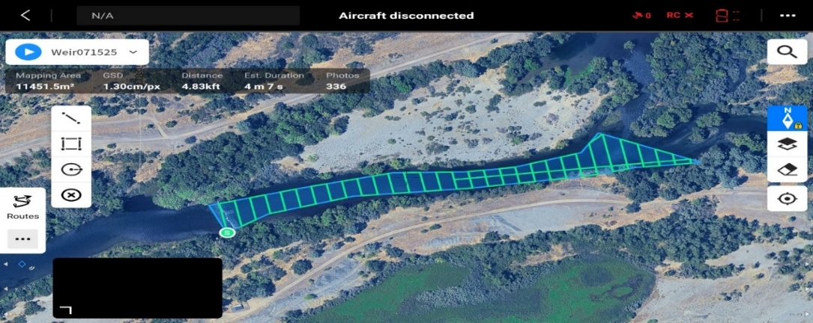

Figure 1. Screenshot from DJI handheld controller showing the drone flight route polygon for Weir Riffle in the LFC. The green line indicates the drone’s flight route.
All flight routes are flown at an altitude of 120 to 150 feet above ground level (AGL). This altitude provided a ground sampling distance (GSD) of 1.0 to 2.0 cm/pixel for the finished orthomosaics. Ground sampling distance represents the distance between the centers of two adjacent pixels on the ground surface depicted on the orthomosaic image. A lower GSD value indicates the pixels in the image represent smaller areas on the ground resulting in higher resolution and more detail.
The photos taken by the drone are saved to the drone’s onboard SD card. The SD card is removed from the drone and the photos from all completed flight routes are downloaded to a computer at the Feather River Section office.
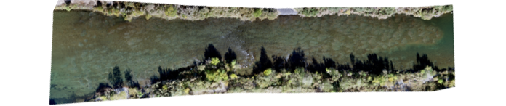
Pix4D Mapper photogrammetry software is used to combine all the photos for each flight route into a single georectified orthomosaic image for the area flown (Figure 2).

Figure 2. Orthomosaic of Bedrock Riffle from drone photos taken on October 28, 2024.
Each orthomosaic is saved to the computer with a date code of when the flight route was completed. The orthomosaics are then uploaded into ArcGIS Pro to create a basemap of each one of the flight routes (Figure 3). A point feature layer is created with the same date code of the orthomosaic and then a single, colored point is placed on each redd. Each week the newest orthomosaic is layered over the top of the previous imagery and the process of adding a different colored dot on each new redd on the image is repeated to create a comprehensive map for each of the flight routes. Routes that have multiple spawning locations on the orthomosaic require a separate point feature layer for each spawning location. The location name and flight date are added to the layer and then redd points are marked using the same process (Appendix A, B, and C).
The longitude (X) and latitude (Y) coordinates for each point feature on all maps are calculated in ArcGIS Pro and added to the attribute tables for all flight routes and spawning locations.
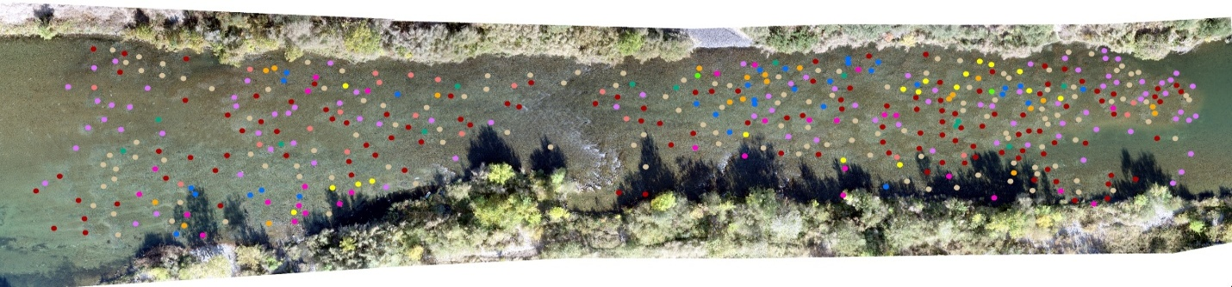

Figure 3. ArcGIS Pro map image of combined point feature layers for redd points at the Bedrock Riffle flight route in 2024.
The X and Y coordinates from each attribute table on the completed maps are exported from ArcGIS Pro to individual Excel worksheets for each flight route. The worksheets are divided into individual flight route and spawning location spreadsheets with the appropriate date code. A new column is added to each spreadsheet, and the flight route or spawning location name is entered for all X and Y data. All spreadsheets for each flight route and spawning location are combined into a single spreadsheet and then these spreadsheets are merged into one spreadsheet that contains all the XY data for the entire survey year.

Appendix A. 2024 UAV flight route schedule for the Aerial Chinook salmon redd survey. (Spawning locations are noted for flight routes with multiple locations)

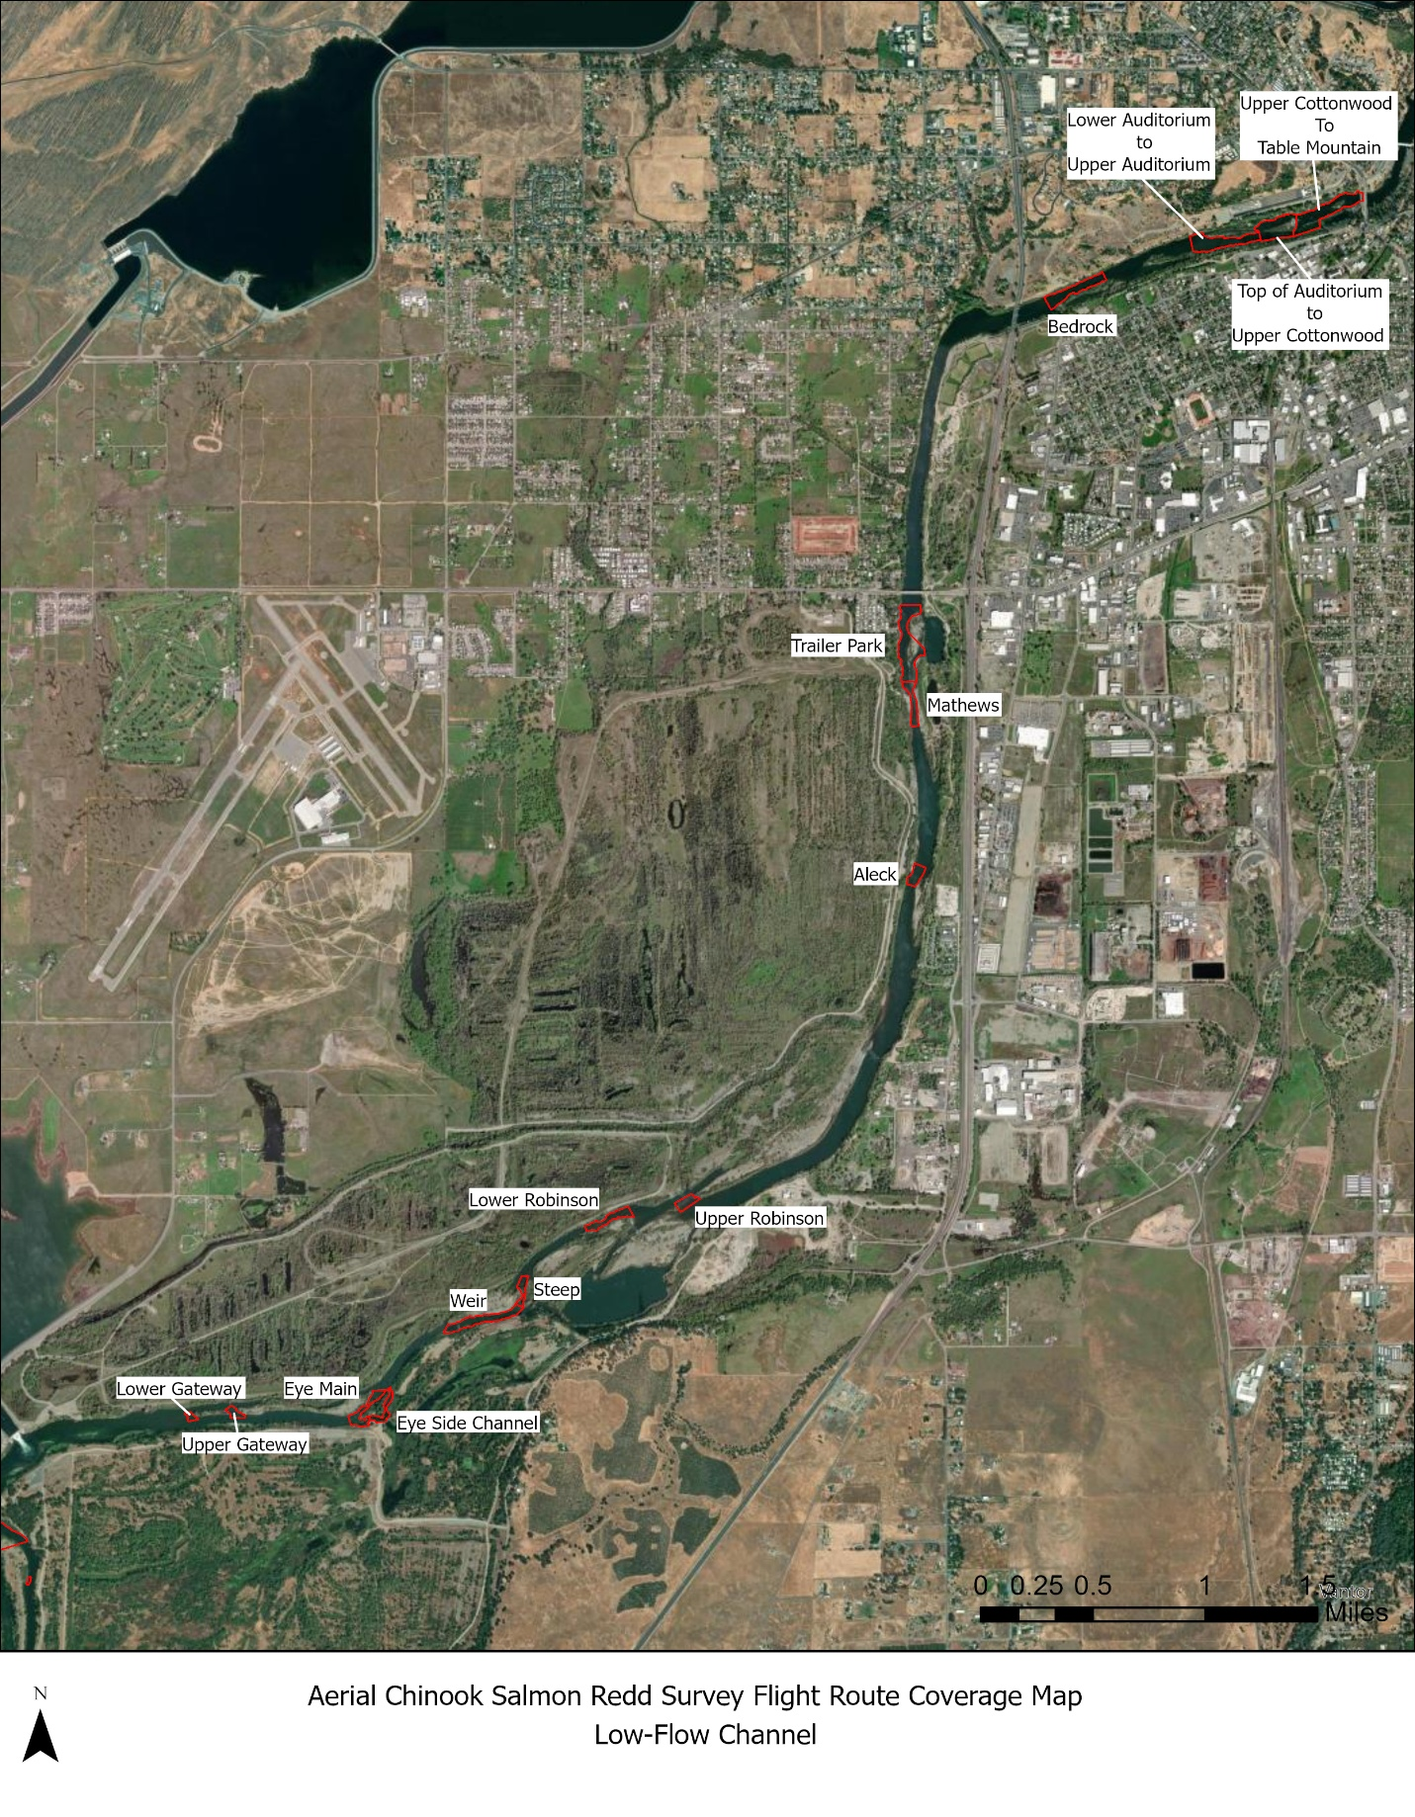
Appendix B. UAV flight route coverage map for the low-flow channel of the Lower Feather River
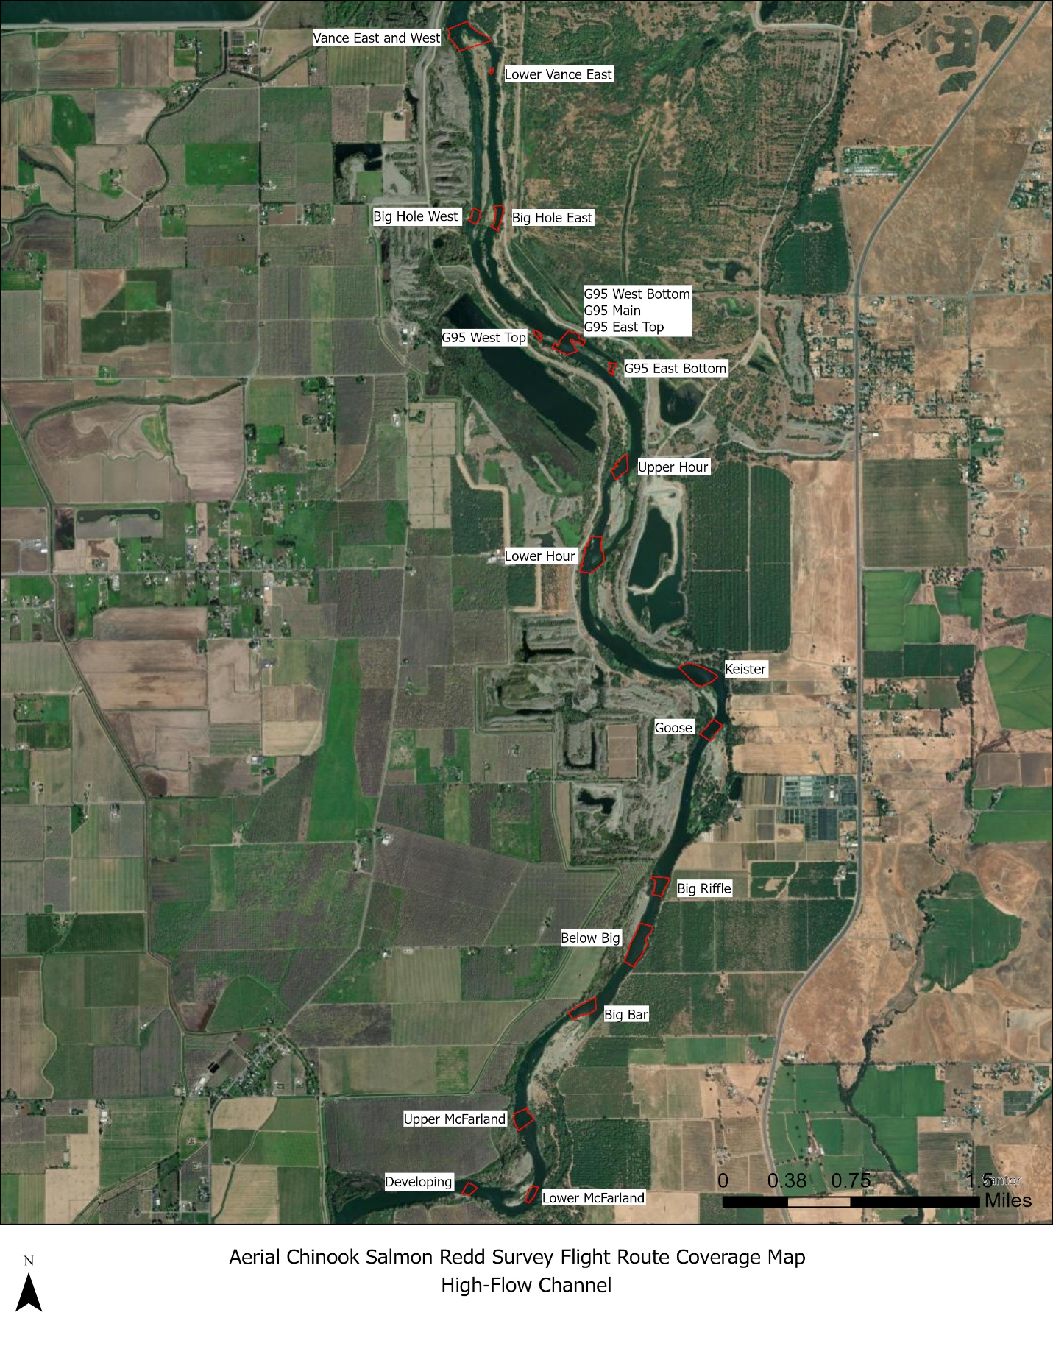
Appendix C. UAV flight route coverage map for the high-flow channel of the Lower Feather River

